# Methodology

Selected methodological approaches in SIVOCS are products of extensive literature research and discussion with multiple experts on social innovation (SI). The general structure of the project SIVOCS included a survey directed to a representative sample of the researchers from the projects funded by the Swiss National Fund (SNF) and interviews with selected researchers from the respondents of the survey. The selection criteria of the interview candidates were decided in the preliminary analysis process of the survey results.

Survey questions are directly related to the question either asked/analysed in the related literature or have been derived from the discussion on the contemporary SI literature. Almost all of the survey questions were directed to test specific hypotheses; some were interested in analysing if a specific variable/question was statistically significantly different between varying scientific domains[1], and others were more interested in relations/correlations between different variables measured by the survey questions. The variance of some variables (e.g. similarity of age groups among the respondents) was not eligible to test hypotheses associated with those questions, but other than a wide range of hypotheses were able to get tested with the survey results.

Before the appliance of statistical tests, the distributions of the survey questions were considered to decide for appropriate hypothesis testing methods. The distribution of the survey responses only rarely resembles a normal distribution; therefore, it has been decided accordingly to apply non-parametric statistical tests to test the hypotheses. Following this decision, for the test of correlations, the survey analysis used Spearman’s method as it is performing also better with relatively less linear relations between variables. All the analysis, hypothesis testing, and visualisation process are run mostly with the statistical programming language R and Python. Furthermore, an extensive dimension reduction process with Principal Feature Analysis (PFA), Explanatory - & Confirmatory Factor Analysis (EFA, CFA) has been applied to build a model to define and measure most important aspects of the SI as well as to create an SI-index that orders the projects in terms of SI-contribution rate.

A further appliance of the SI-index introduced by the dimension reduction process is to test the final hypothesis concerning the survey. The final hypothesis of the survey is comparing the self-assessment SI-Rate which has been asked to the survey participants and the SI-index derived from own methodological approach.

# Sample Distribution

# Familiarity with SI and Transdisciplinarity

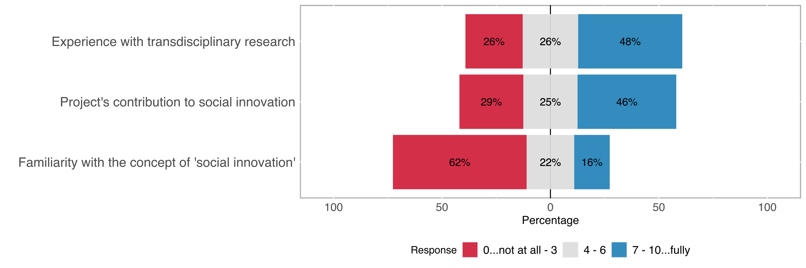

Figure 1: The distribution of SI-familiarity, familiarity with transdisciplinarity and contribution to SI rate (self assessment)

## Experience with transdisciplinary Research

The majority of the survey respondents are somewhat experienced in transdisciplinary research approaches, only 26% of the respondents rated their transdisciplinary experience lower than or equal to 3 on a scale of 0 - 10. Close to half of all survey respondents (46%) note their especially high levels of experience in transdisciplinary methods.

Transdisciplinarity is not a condition for SI, however, it is usually an important cornerstone in the setting of socially innovative outcomes. Transdisciplinary experience of the researchers does not directly implicate higher chances for social innovation in the research project but (H) *we assume that it is often in relation with not (purely) academic motivation to conduct research*.

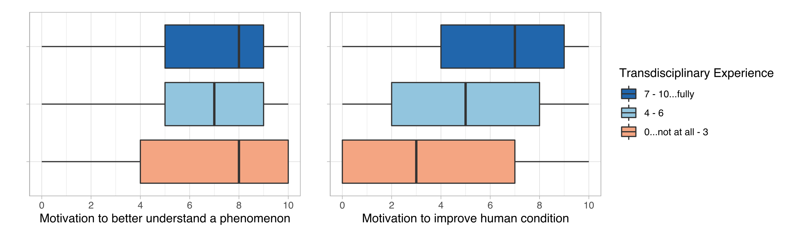

Figure 2: Relation between the rate of transdisciplinary experience and non-academic motivation

The survey questions motivation to *directly address a natural, technical, economic, or social problem* and *to improve the human condition/welfare[2]* are directed to the measure non- or only partially academic motivation. The analysis of the relation between the rate of transdisciplinary experience and the motivation to address a (non-academic) problem (see Figure 2) does not yield any significant correlation between the variables (correlation coefficient rho[3] ~0.01), to be motivated to address a natural, technical, economic, or social problem directly does not seem to be getting higher with higher rates of transdisciplinary experience. The motivation to improve the human condition is on the other hand correlating relatively stronger with transdisciplinary experience, although a statistically significant relation (p-value < 0.05[4]) there is only a weak positive correlation (rho ~0.33). The motivation to improve human welfare/condition is getting only slightly higher with higher transdisciplinary experience.

## Familiarity with social innovation

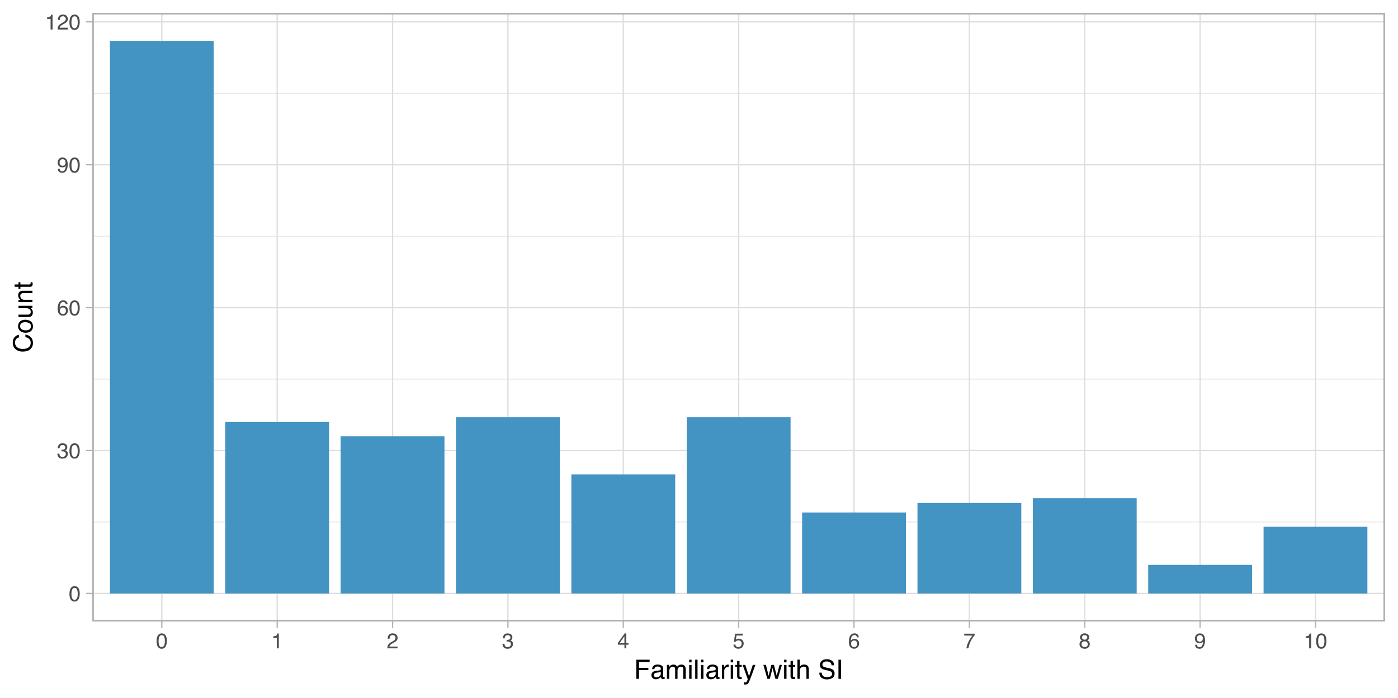

Figure 3: Distribution of the rate of familiarity with social innovation

Social innovation is a relatively less known concept among the survey respondents. The majority of the respondents indicated their low familiarity with SI, approximately %32 of the respondents selected the lowest level of SI-Familiarity (indicated with 0) and only 16% of the respondents selected a value equal or greater than 7 on a scale between 0 to 10.

One of the literature-driven assumptions about SI-familiarity was that [H] *the SI-Familiarity depends on the scientific domain*. Considering the survey results are strongly skewed towards low familiarity rates, a possibly significant difference between the main scientific domains is an especially important aspect towards an understanding of SI in research.

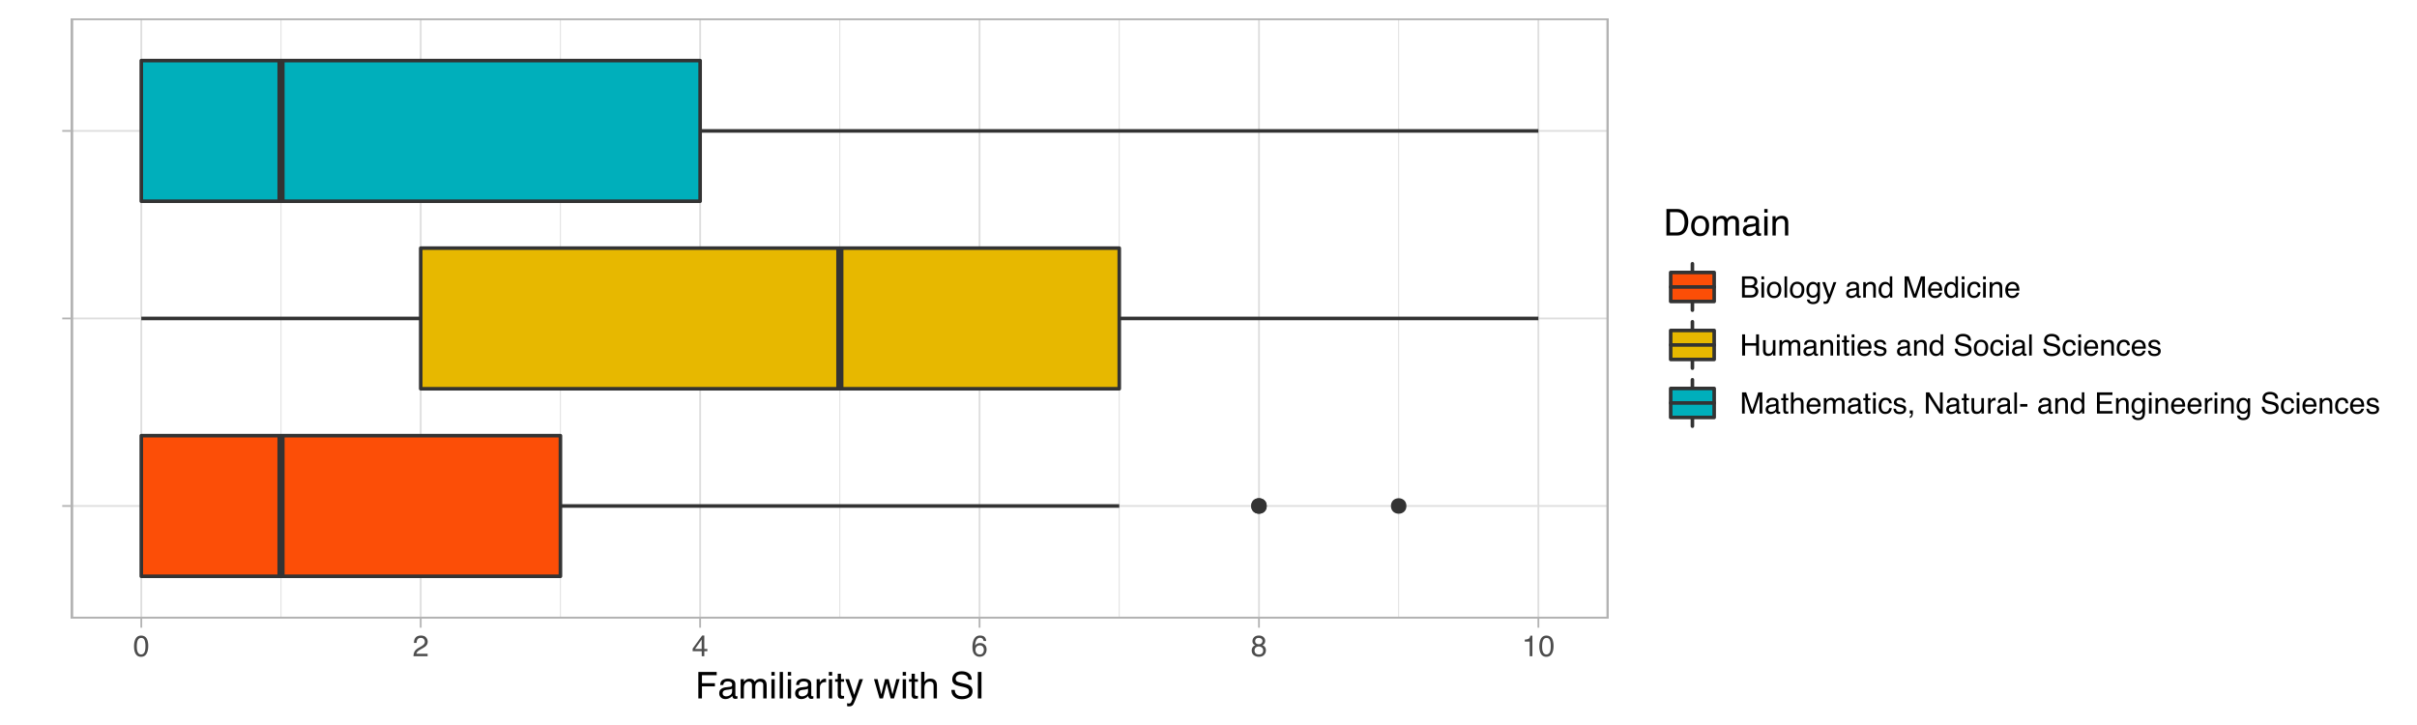

Figure 4: Distribution of the familiarity with SI among different scientific domains

The analysis of the survey results yields a statistically significant dependence of the SI-familiarity to the scientific domains (Kruskal-Wallis [K-W] rank sum test p-value < 0.05). However, as Figure 4 also visualises, the domains Mathematics, Natural -, & Engineering Sciences and Biology & Medicine are statistically not significantly differ from each other while Social Sciences and Humanities (SSH) show a stat. significant difference to both of the other domains [5].

## Contribution to SI (self-assessment)

# Intention & Agency

## Motivation types

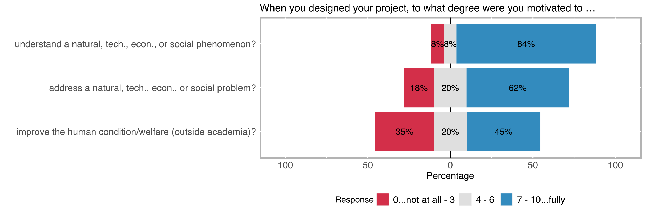

The type of motivation that drive academicians to conduct research is an important indicator of the content, structure, and results of the study. The initial motivation types are measured in the survey under 3 main categories, namely, motivation to *better understand a natural, technical, economic, or social phenomenon* (purely academic motivation), to *directly address a natural, technical, economic, or social problem,* to *improve the human condition/welfare* (non-academic motivation).

Purely academic motivation was strongly emphasized in the survey results, 84% of the survey respondents marked academic motivation greater or equal to 7 on a scale between 0 and 10. Followed by motivation to directly address a problem with 64% of the respondents note equal or higher rates than 7. Improving the human condition/welfare, the purely non-academic motivation, was more balanced in comparison. 35% of the respondents replied with rates equal or smaller than 3 and 45% with rates equal or higher than 7 in terms of improving the human condition/welfare being one of the main motivations in their research project.

Social innovation does not necessarily be driven by socially oriented motivation; purely academic research questions can lead to the socially innovative outcomes as well. However, [H] we are expecting a significant correlation between the motivation to improve human condition/ welfare and the following outcome types[6] that indicate the direct contribution of the project results to new or better services, products, processes, or ways of doing things that were targeted towards:

* the general population,
* specific social groups (e.g., women/men/non-binary, youth/elderly; migrants; or minorities/indigenous people),
* NGOs, advocacy, or other civil society groups.

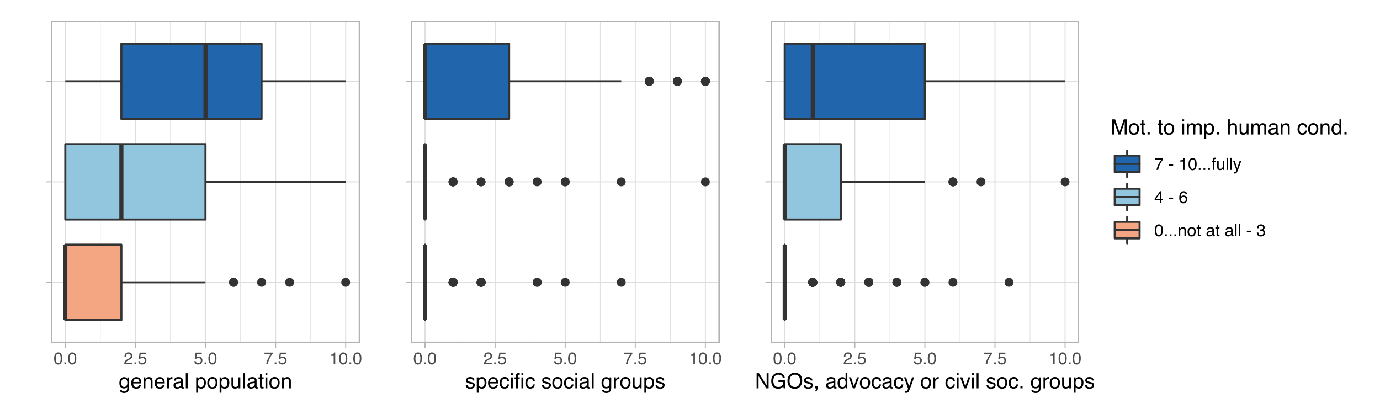

Figure 5: Relation between the motivation to improve human condition/welfare and the direct contribution of the project results towards...

Motivation to improve human condition shows statistically significant correlations with each of the outcome variables (p-values < 0.05). The strongest correlation is a moderate positive correlation with the direct contribution to new or better services, products, processes, or ways of doing things that were targeted towards the general population (rho = ~0.5).

## Impulses from the non-academic world

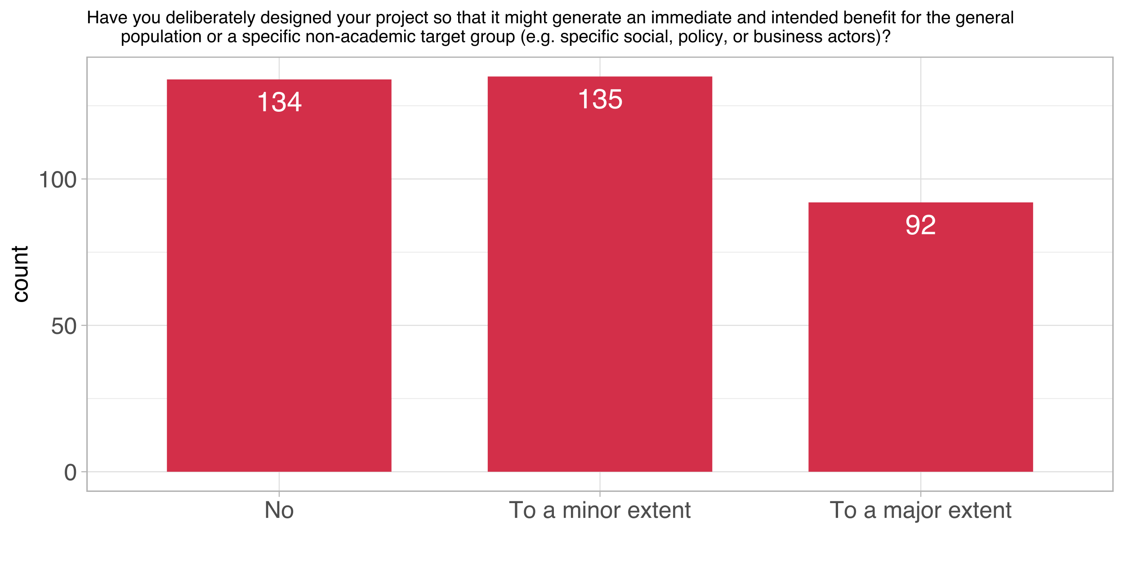

Figure 6: Distribution of impulses from the non-academic world

Following the non-academic motivation to conduct research, the variable impulses from the non-academic world targeted the research projects deliberatively designed to benefit a specific non-academic societal group. In this sense, the strive towards societal benefit is more emphasized in this particular survey question. Approximately 37% of the respondents not that their projects did not include a presetting specifically designed to benefit a social group. Almost exactly the same amount of respondents indicated this type of deliberative design was only present to a minor extent in their research projects. Although a smaller proportion a significant part, 25% of the respondents noted that the design of their projects was specifically targeted creating benefit for a social group.

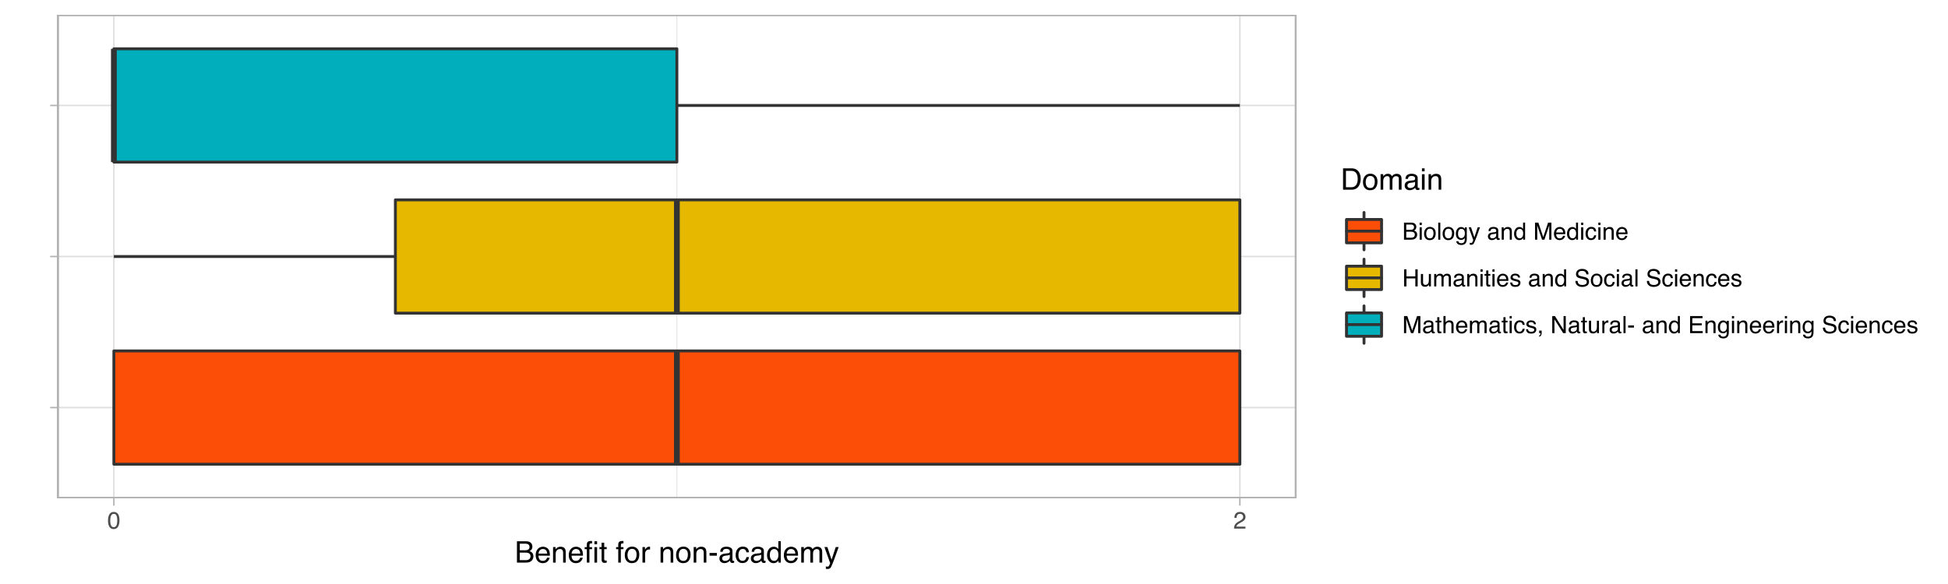

Figure 7: Deliberative design of the research for the benefit of non-academic groups among scientific domains

Similar to the familiarity with SI, differences of dependance of the deliberative design for social benefit among different domains is a

The deliberative approach to benefit for non-academic society shows statistically significant difference between different domains (K-W p-value < 0.05), however while there is a stat. significant difference between SSH and Physical Sciences as well as between Biology & Medicine and Physical Sciences, there is no stat. significant difference between SSH and Biology & Medicine (also visualized on the Figure 7).

We also assume [H] *that the nature of the transdisciplinary involvement of the citizens in the research projects tend to be more active with the higher levels of deliberative research setting towards societal benefit*.

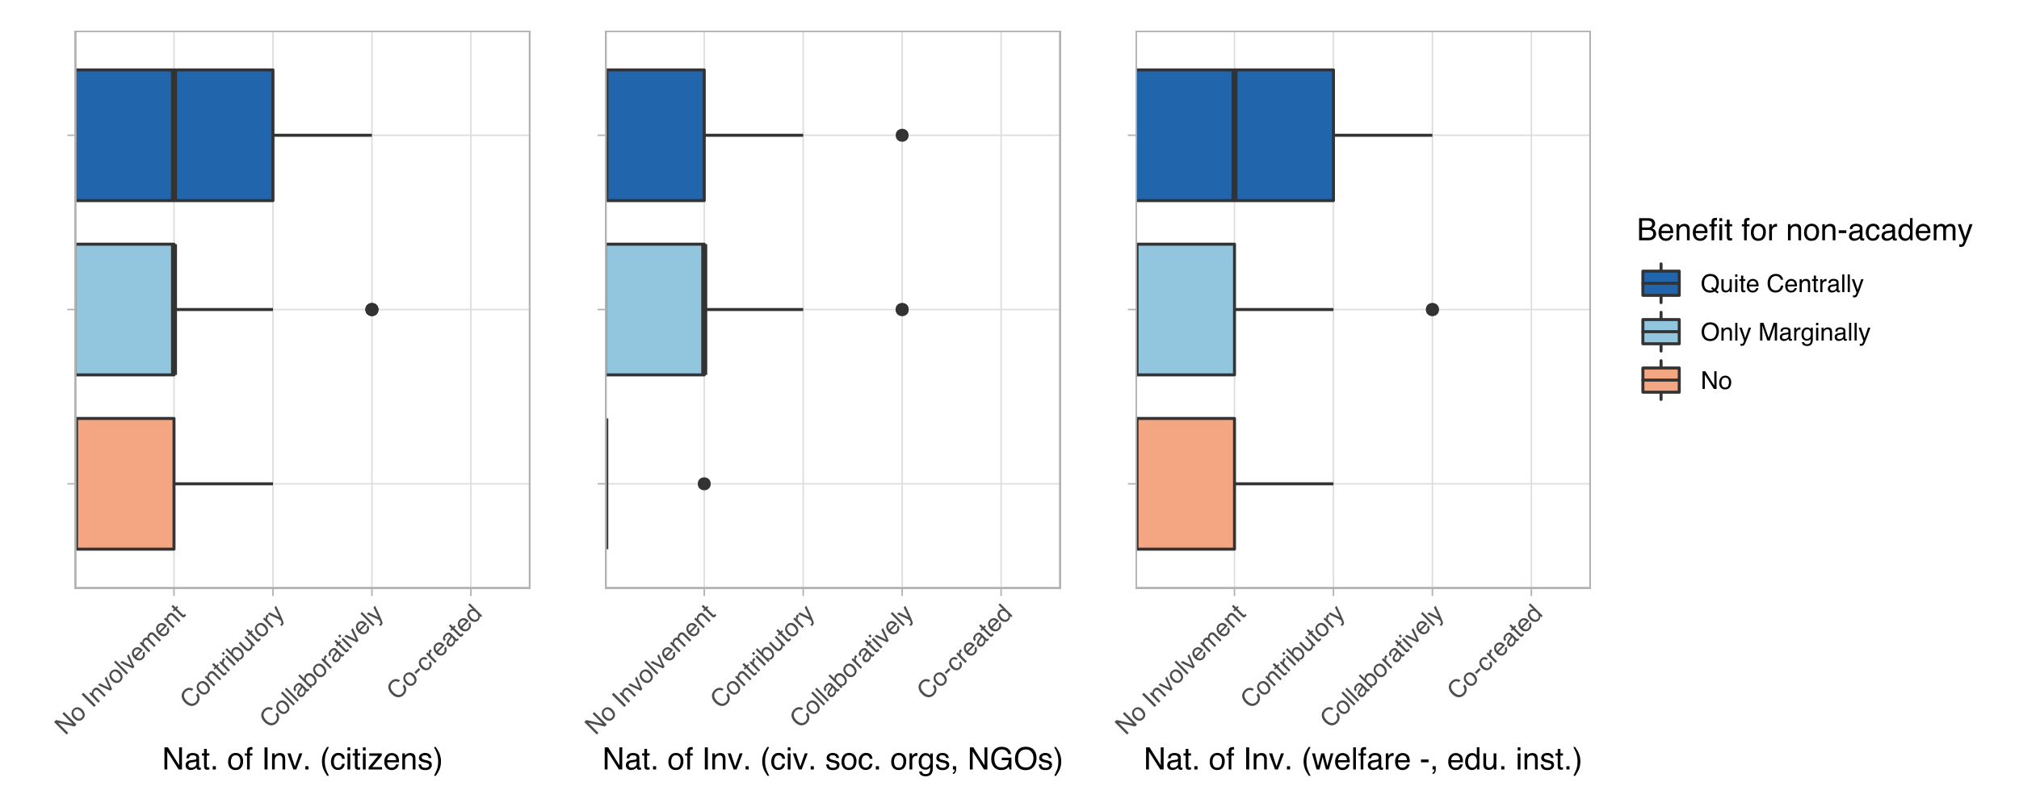

Figure 8: Relation between deliberative design for non-academic benefit and the nature of involvement of...

The nature of involvement of specific groups indicates how far the involvement of those were in the project (for a detailed analysis of the variables see *Nature of Involvement* under Section *Actors & Networks*). 3 different societal categories of the *Nature of Involvement,* namely Citizens, civil society organisations & NGOs, and welfare & educational institutions are chosen to test the hypothesis.

The correlation between the deliberative design of the research for the benefit of non-academic societal groups and the nature of involvement of citizens as well as civil society organisations & NGOs is very weak (rho < 0.15 for each) and not statistically significant. Only stat. significant relation is with the nature of involvement of the representatives from welfare and educational institutions with a weak correlation (rho ~0.3). Although there is a slight relation, deliberative design to benefit specific societal groups does not seem to be correlate well with the deeper involvement of the societal groups in the study in terms of transdisciplinary engagement.

## impulse from the non-academic world

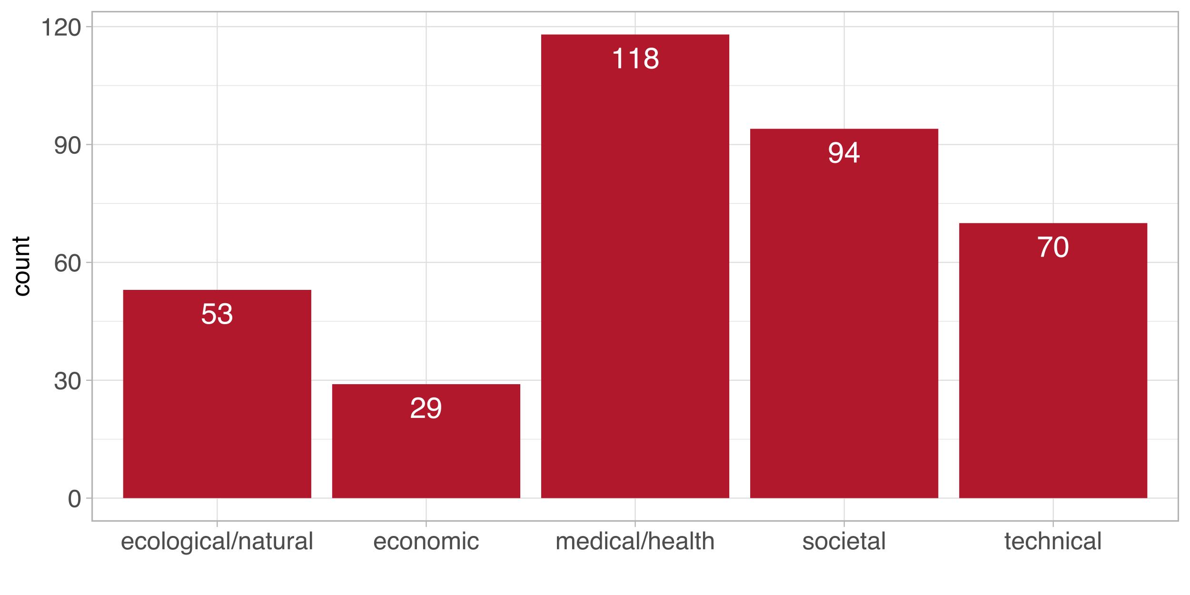

Figure 9: Distribution of impulses from the non-academic world

# Actors & Networks

## Level and nature of inter-/transdisciplinary involvement

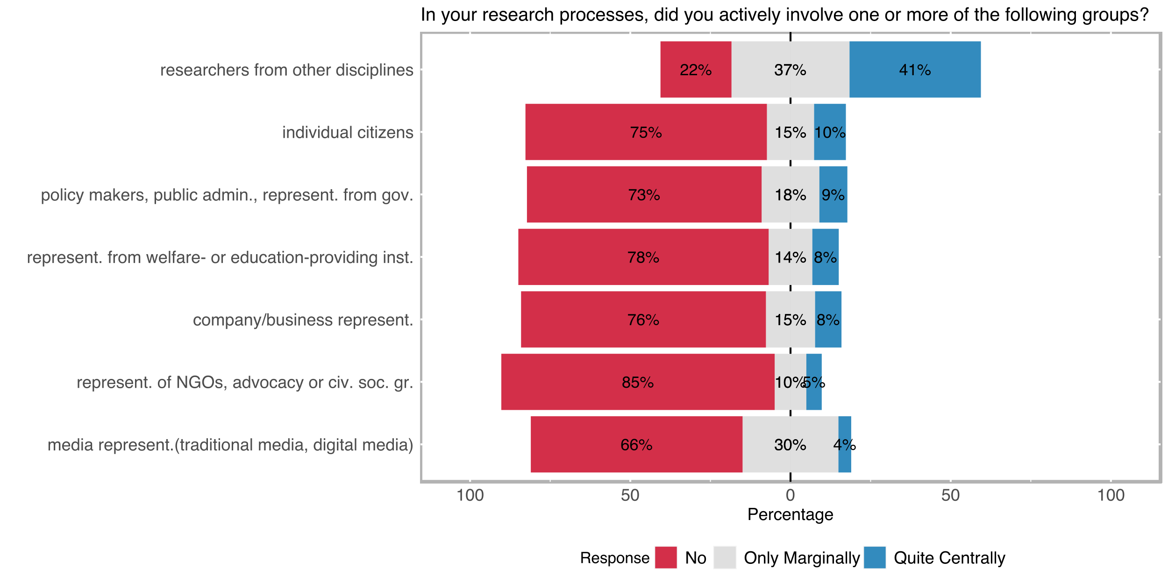

Figure 10: Level of interdisciplinary and transdisciplinary involvement

Interdisciplinary involvement is common among the SNF funded projects, 41% of the respondents note that the involvement of academicians from other disciplines were quite central to their specific project (see Figure 10), in total 78% of the projects were carried out with the collaboration of researchers from other disciplines. Transdisciplinary involvement has been measured under different categories which indicate the inclusion of different type of societal actors and groups in the research process. Although not as central as the interdisciplinary involvement different types of transdisciplinary engagement constitute a noteworthy part of the research projects. Transdisciplinary involvement types yield somewhat similar distributions among the projects of the survey respondents.

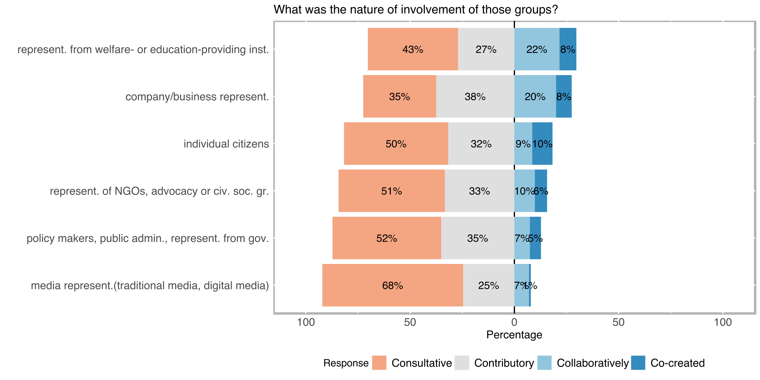

Figure 11: Nature of transdisciplinary involvement

Although the centrality of involvement delivers a good indication how far specific groups were involved in the project, in the case of transdisciplinarity the role of participated social groups are often overlooked. Motivated by our literature research we have decided that the *nature of involvement* (indicated with the labels; *consultative, contributory, collaboratively, co-created*) carries at least as much information as the centrality of the involvement about the occurrence of SI-related aspects.

As Figure 11 displays transdisciplinary involvement mostly consultative or contributory in nature. Collaborative transdisciplinary involvement is relatively more likely when welfare/education institutions or company/business experts are involved in the project (20% and 22% respectively). Co-creation is a rarity in all of the defined transdisciplinary involved categories, the highest co-creative involvement belongs to the projects that include individual citizens (10%).

Participatory research design is often aiming to mobilize specific social groups’ potential in order to create an action and change by the direct collaboration of those who were affected by the issue being studied[7]. Transdisciplinary involvement of citizens, therefore, is often associated with SI-related outcomes. Therefore, [H] we are expecting more central engagement of the individual citizens with higher levels of SI-Familiarity.

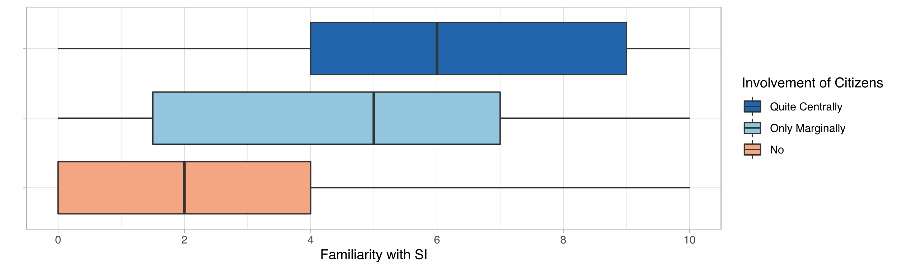

Figure 12: Relation between SI familiarity and the level of involvement of individual citizens

SI-familiarity and individual citizens’ involvement correlate moderately positive (rho ≈ 0.4, p-value < 0.05; see Figure 11). Although, this is not a particularly strong correlation, it indicates higher chances of involvement of the individual citizens in the projects of the researchers with high familiarity with SI.

Transdisciplinary approaches are often applied to capitalize on the ability of non-academic actors to address a previously unknown or only partially explored issue. The nature of involvement is an important indicator about what kind of a role transdisciplinary participants played. [H] We are expecting, with further levels of involvement higher levels of addressing a previously unknown (or only partially explored) issue (for a detailed exploration of the variable, see Section *Outcome Orientation*)

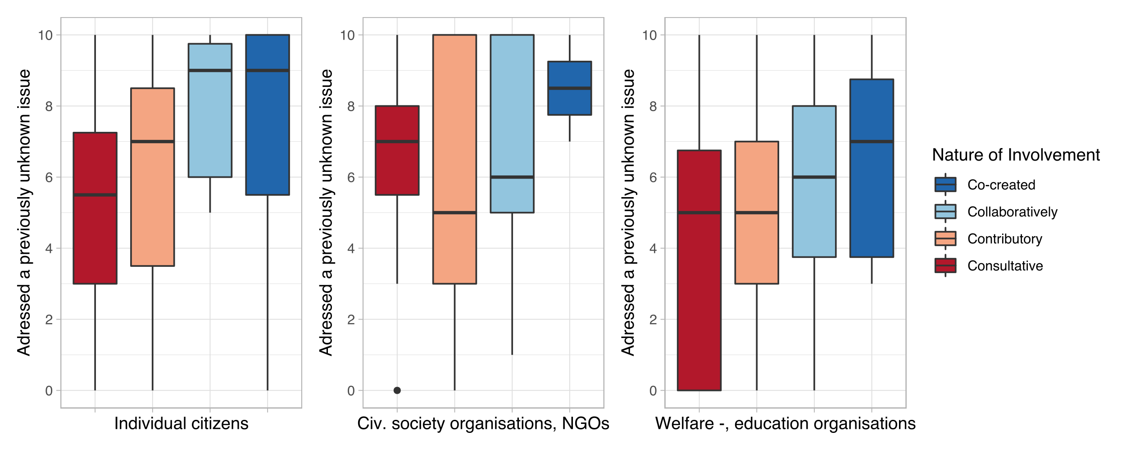

Figure 13: Relation between the nature of involvement of specific societal actors and groups with novelty of addressed issue

The nature of involvement regarding the citizens seems to have a statistically significant relationship with the novelty of addressed issue (p-value < 0.05), however, it is a weak positive correlation (rho ≈ 0.3). The correlations with other societal groups like civil society organisations, NGOs, welfare -, educational organisations are even weaker (rho < 0.25). In this sense, novelty of the addressed issue does not seem to strongly indicate transdisciplinary involvement of societal groups.

Another expectation from the stronger forms of participatory involvement is to develop wider impacts and scalable solutions. The central involvement of the citizens should in the study should allow the creation of more widely applicable results and increased impact for the involved individuals. In this sense, [H] we are expecting following relations with the *more* *central involvement of individual citizens*:

* scalability of the results[8],
* generating a deeper/better understanding of a specific social issue,
* emancipatory impact of the study on participating groups.

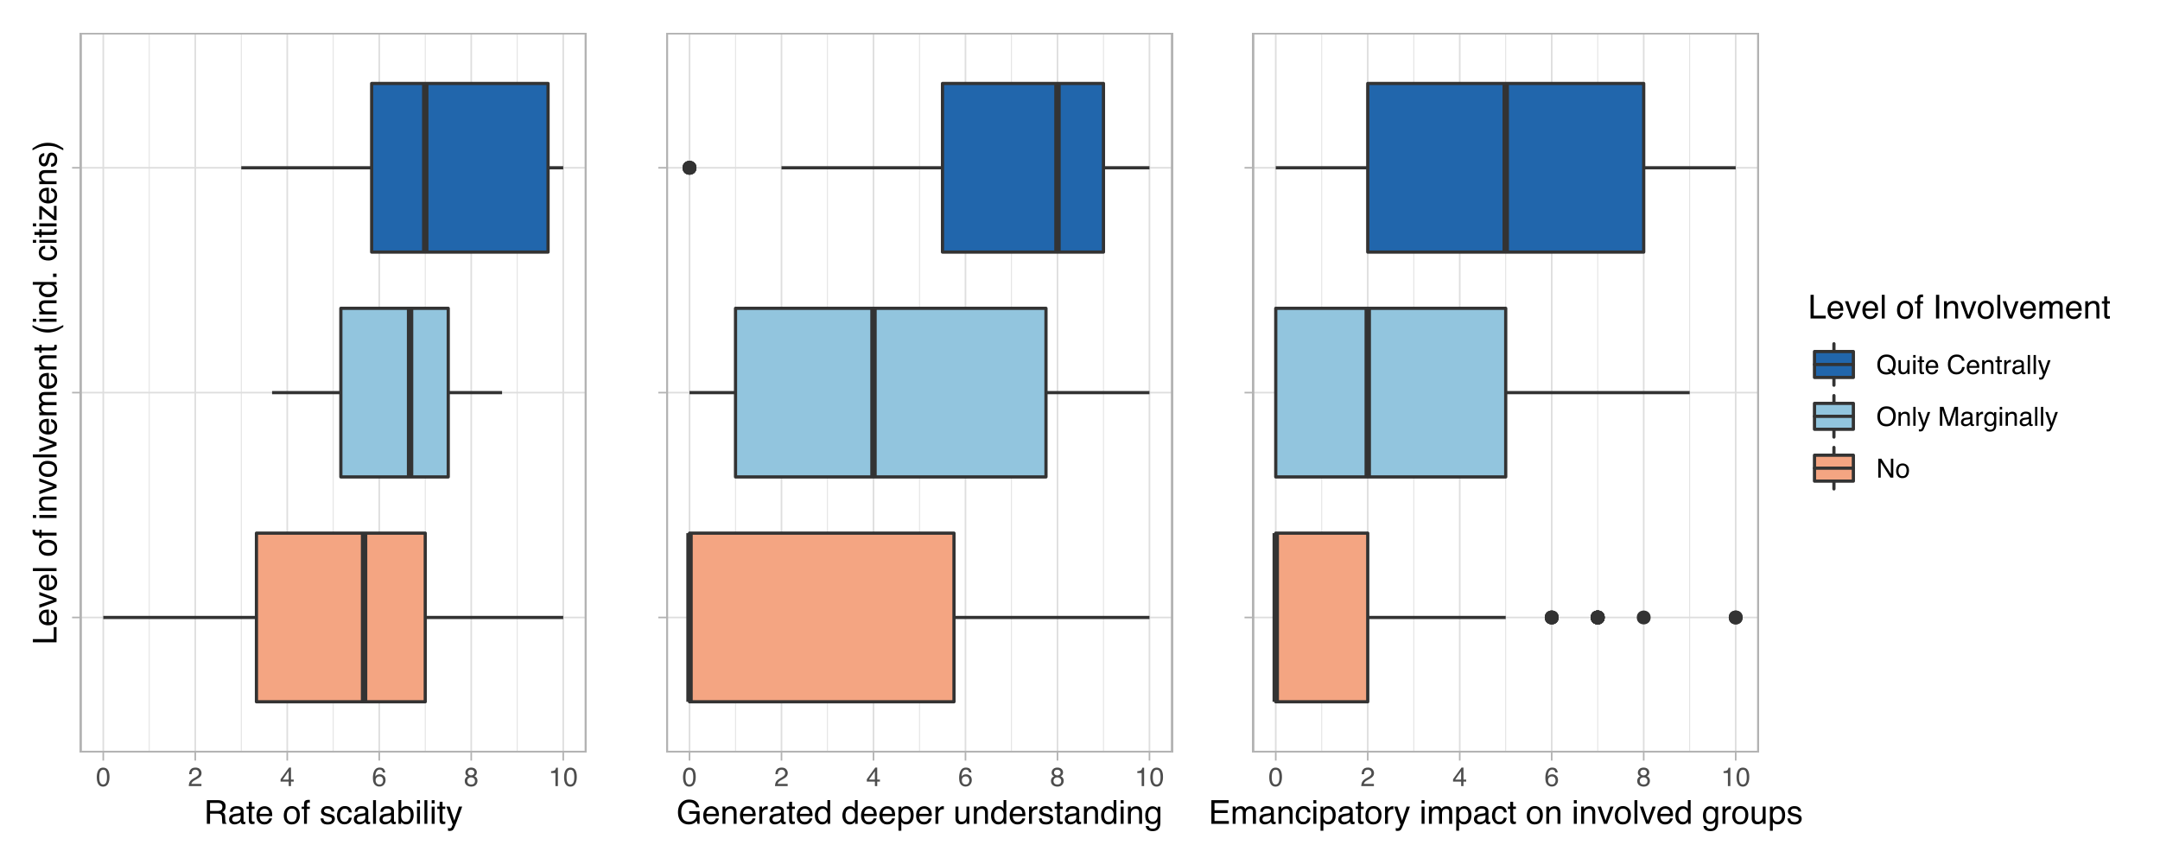

Figure 14: Relation between citizens' level of involvement and selected outcome variables

Scalability seems to be rated slightly higher in the research projects with central involvement of the citizens (rho ≈ 0.35, p-value < 0.05). Generating a better/deeper understanding as well as the emancipatory impact on the involved societal groups seem to be correlating relatively higher in comparison (rho > 0.45, p-value < 0.05 each). Higher levels of transdisciplinary involvement of the citizens have a statistically significant relation to the scalability of results, deeper/better understanding of the studied issue, and the emancipatory impact on the participating societal actors.

## Target Group Goals

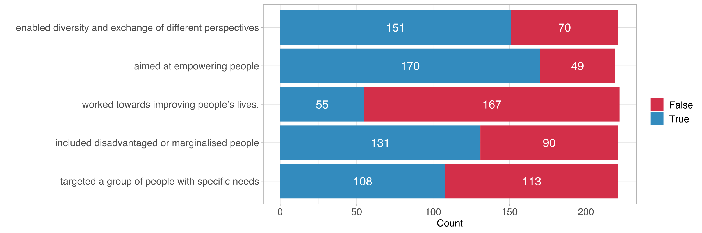

Figure 15: Distribution of target group goals

Envisioned social goals of the project can be important indicators of social innovation. Several true/false statements concerning with foreseen social impact and social inclusion goals were directed to measure further aspects of transdisciplinarity. *Aim to empower targeted or included social groups* was the most frequently selected category (170 times) followed by *enabling diversity and exchange of different perspectives* (151 times). The category the project worked towards imporving people’s lives was the least frequent selected category (55 times).

# Regulatory Framework

## Open Science Concepts

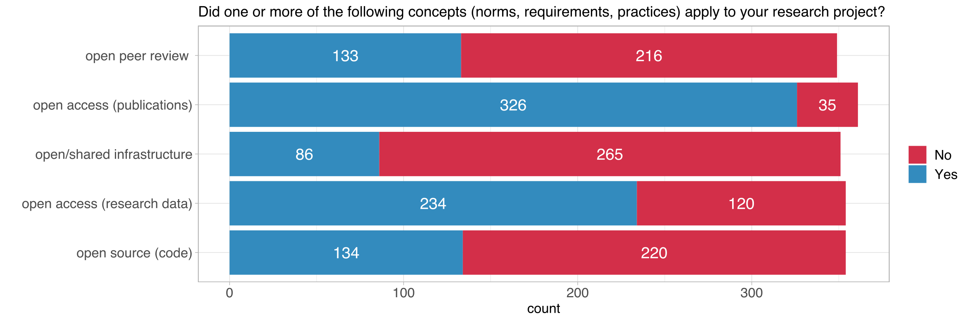

A critical part of carrying out the social goals envisioned in the research process is to ensure project results are available for a broader audience, therefore, open science practices are also important parts of the social impact. Survey results display that the most frequent selected category was *open access publication* (326 times, ~90% of the survey respondents), followed by *open access data* (234 times).

Following the dependence of social impact on the accessibility of results, [H] we assume that the number of open access practices tend to rise with higher levels of transdisciplinary experience.

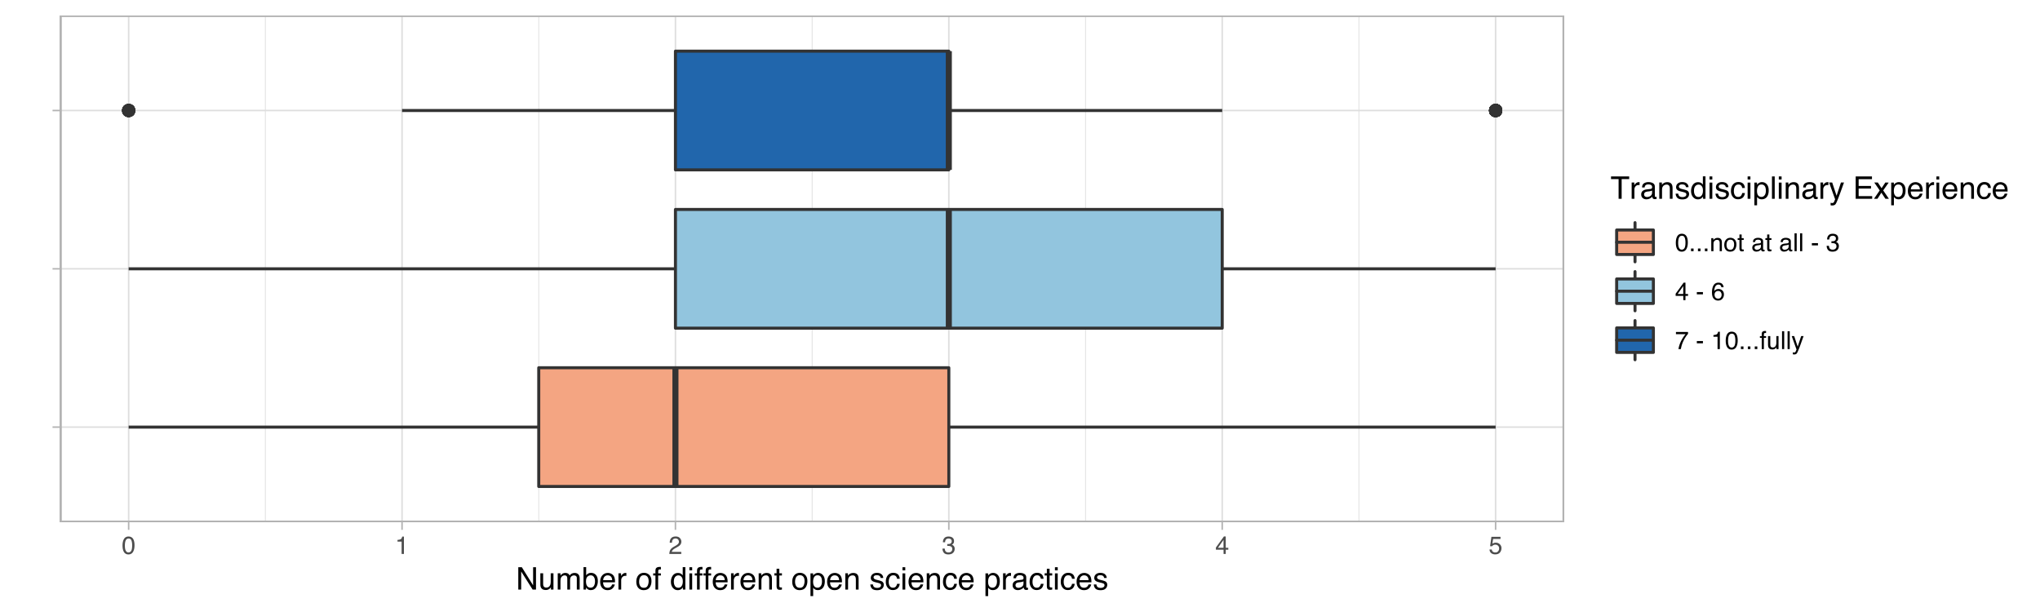

Figure 16: Relation between the number of open science practices and transdisciplinary experience

The analysis yields, however, no correlation between the transdisciplinary experience and the number of applied open science practices as Figure 16 also displays (rho ≈ 0.05).

## Gender Dimension & Support for Policy-Making

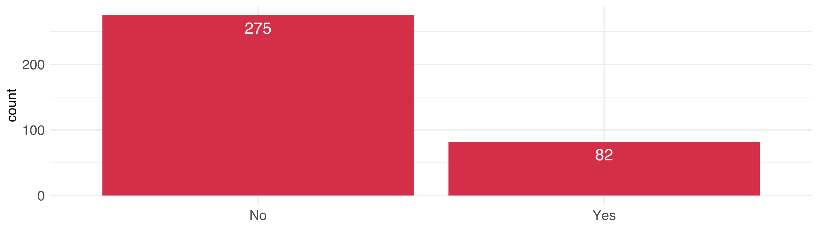

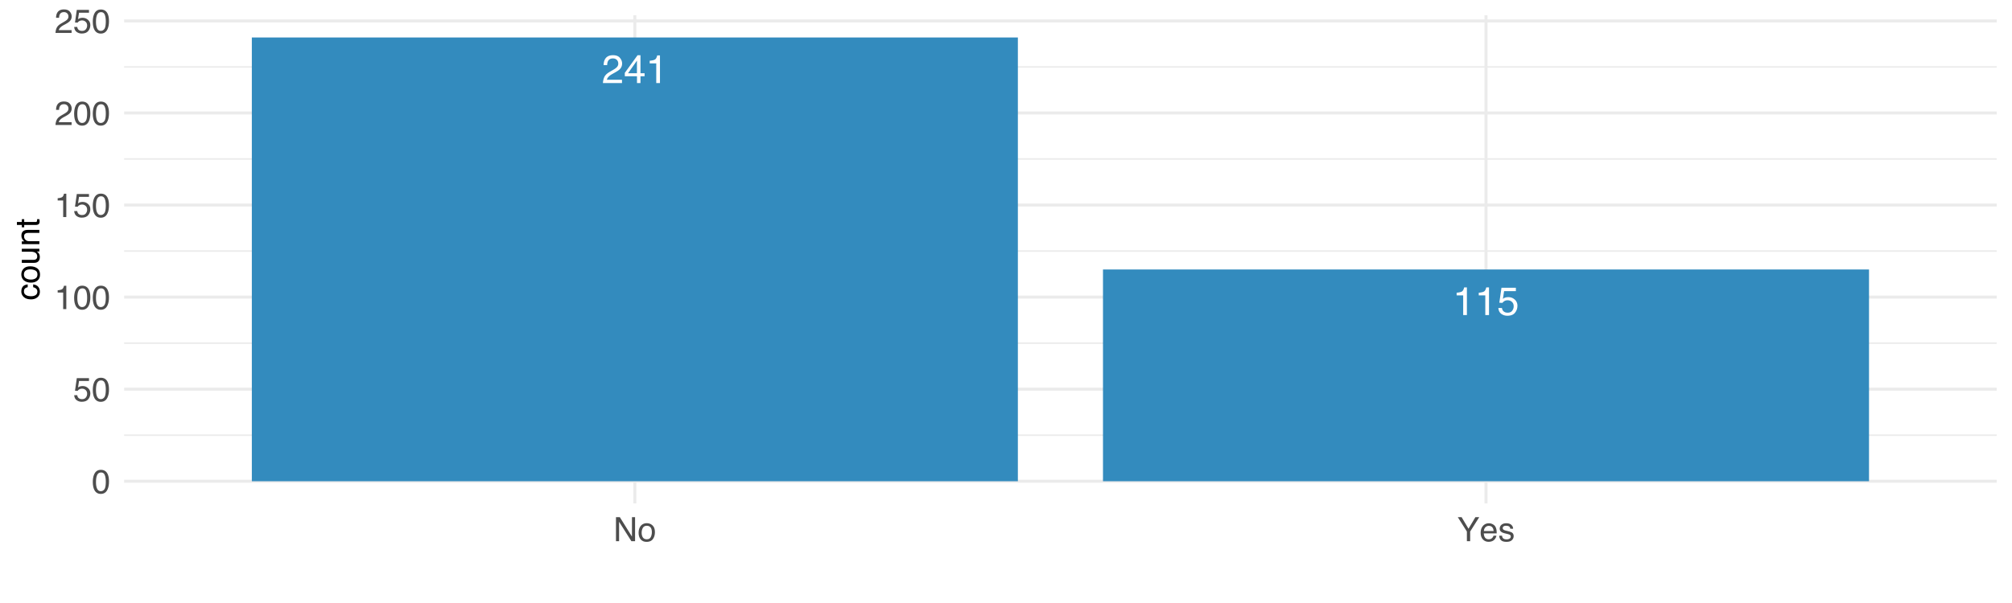

# Outcome Orientation

## Direct Contribution

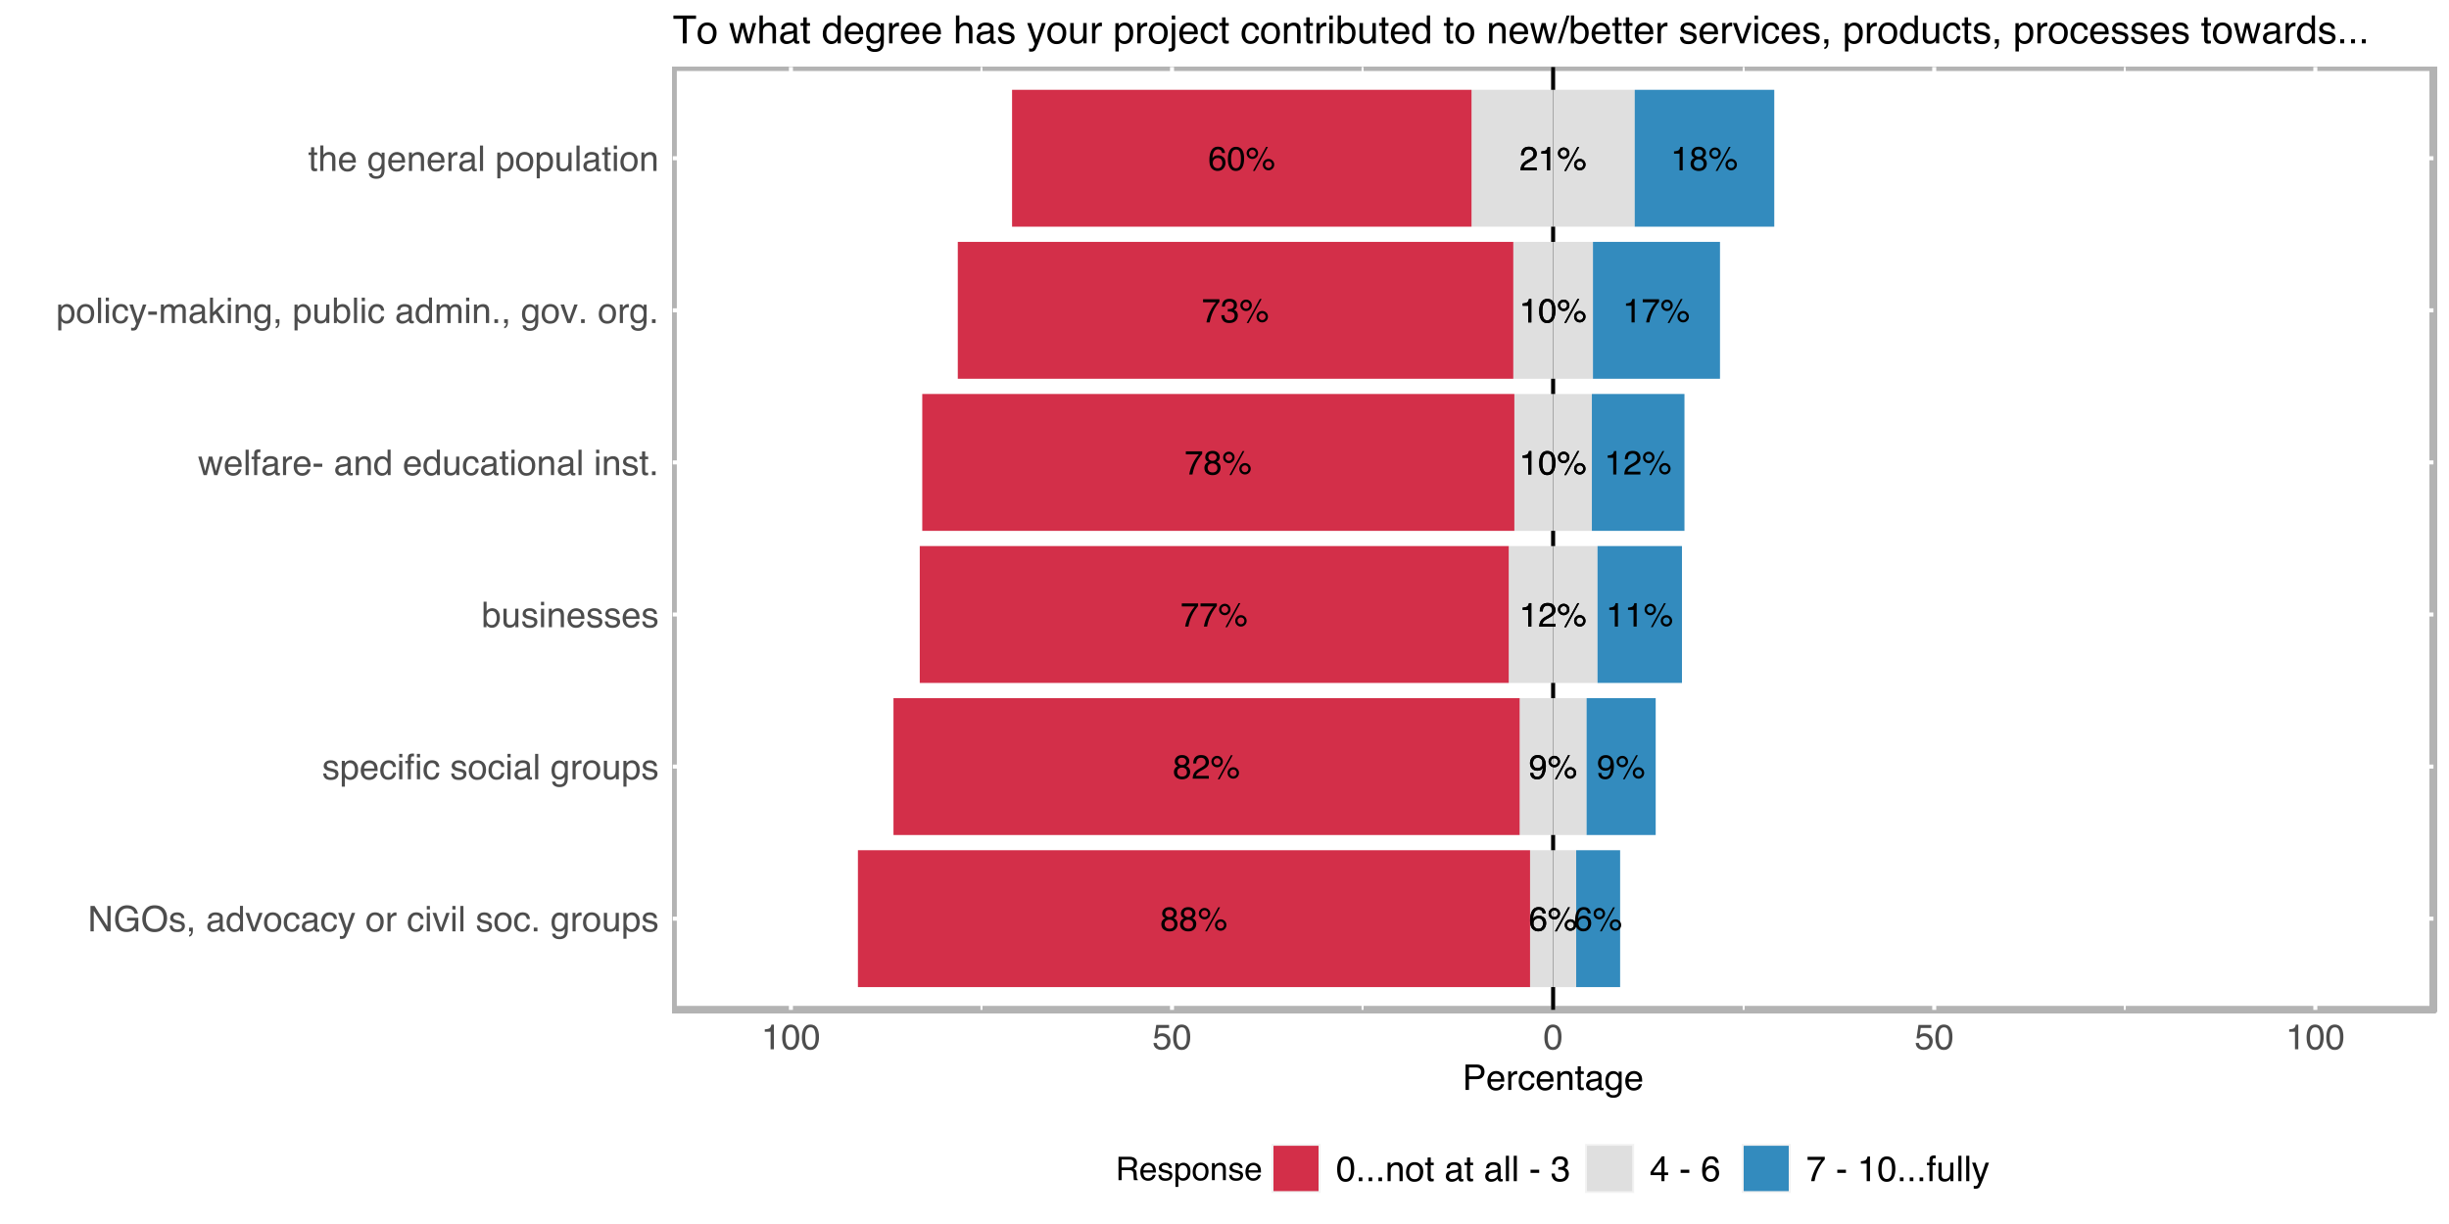

A direct contribution to services, products, processes is not a frequent occasion for research projects. However, although the majority of the respondents marked 3 or smaller values on a scale from 0 to 10 for all of the categories, ~40% of the respondents noted that their project results somewhat directly contributed to new/better products and services for the general population from which 18 % of respondents stated to have strongly contributed to benefit the general population.

Our definition of social innovation includes outcome orientation which includes both the tangible and non-tangible outcomes. Although the direct outcomes are often a rarity among the scientific projects we assume [H] transdisciplinary inclusion of each societal group increases the chances of a direct outcome for that specific group.

## Intended Effects

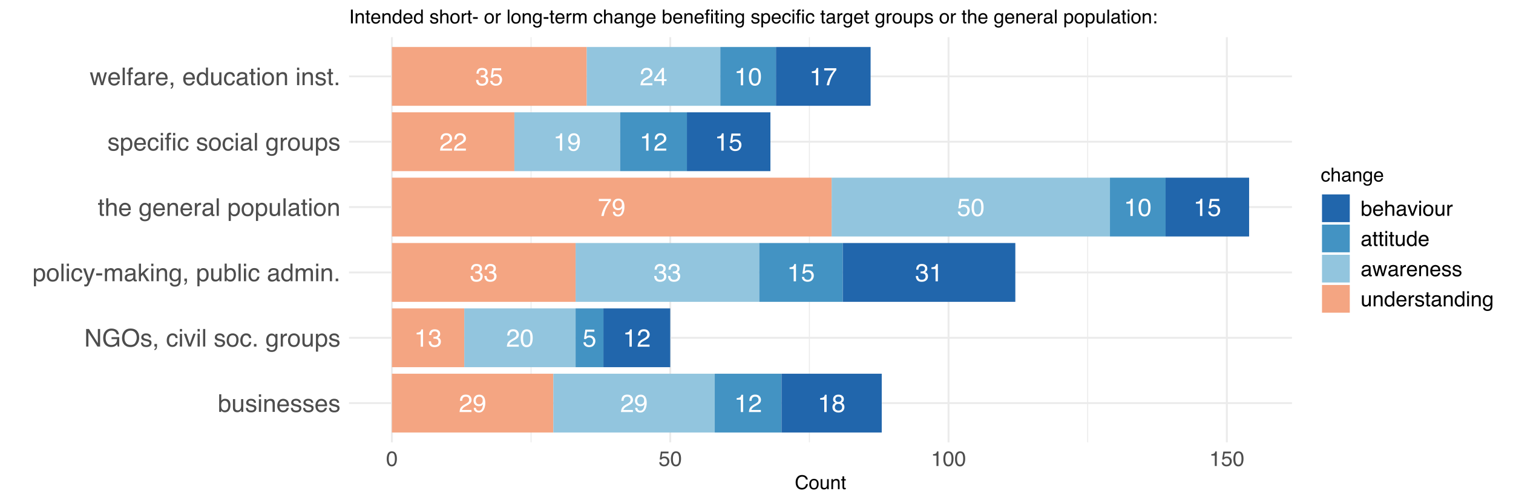

Figure 17: Distribution of intended effect types

The question regarding intended effects is designed to crystallize the information about the outcome potential of the projects without limiting the scope only on the immediate impacts. Instead the kind of change directed to specific social groups is emphasized in order to measure the societal ambitions of the study. *Improving the understanding* as well as *raising awareness* in the general population is by far the most frequently selected categories (79 and 50 times). Other arguably stronger types of changes (attitude and behaviour) are occurring relatively less frequent among all of the defined societal actor categories. However, 31 respondents note the intended effect (or one of the intended effects) of their research project was a behaviour change among the policymakers and/or public administration.

We assume [H] that the nature of involvement of the societal groups is correlate with the intended effects, or with other words, we are expecting to see a higher order of involvement with higher levels of intended effect for a specific group.

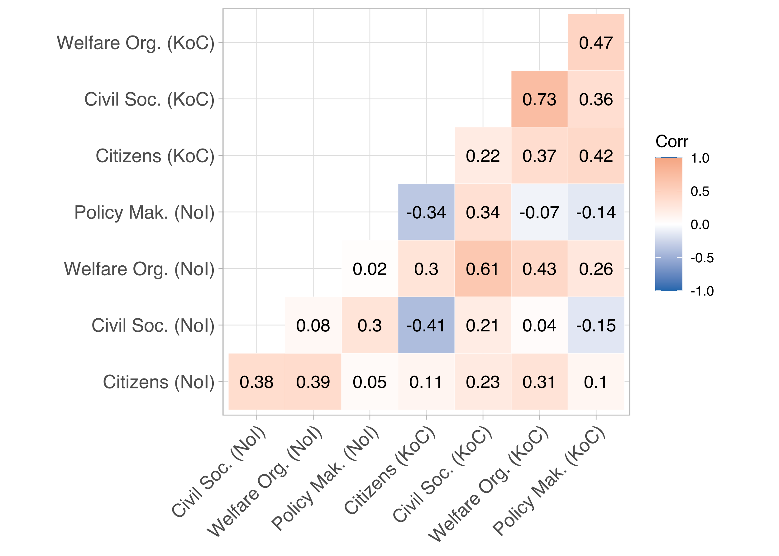[9]

Figure 18: Correlation between the nature of transdisciplinary involvement and intended effects

As the correlation matrix on Figure 18 displays the nature of involvement of a specific societal group does not necessarily correlate well with the intended effects on that specific group.

## Uptake by Decision-Makers

Uptake of the results by policymakers or public administration is a direct indicator of the impact of the outcomes. The survey was designed to explore this aspect under 2 different questions; which were mainly aiming to meaure how far the project results have been adopted by the authorities and what was the nature of the uptake.

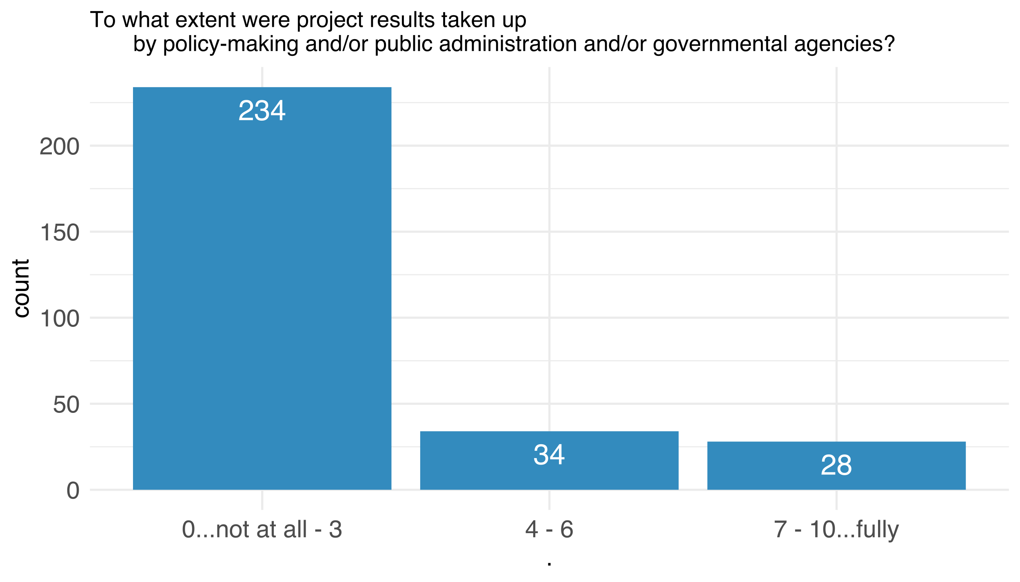

Figure 19: Rate of uptake

Approximately 20 % of the respondents rated the *uptake of the project results by decision-makers* moderate to high. However, an overwhelming majority of the respondents note there was little to no uptake of the project results.

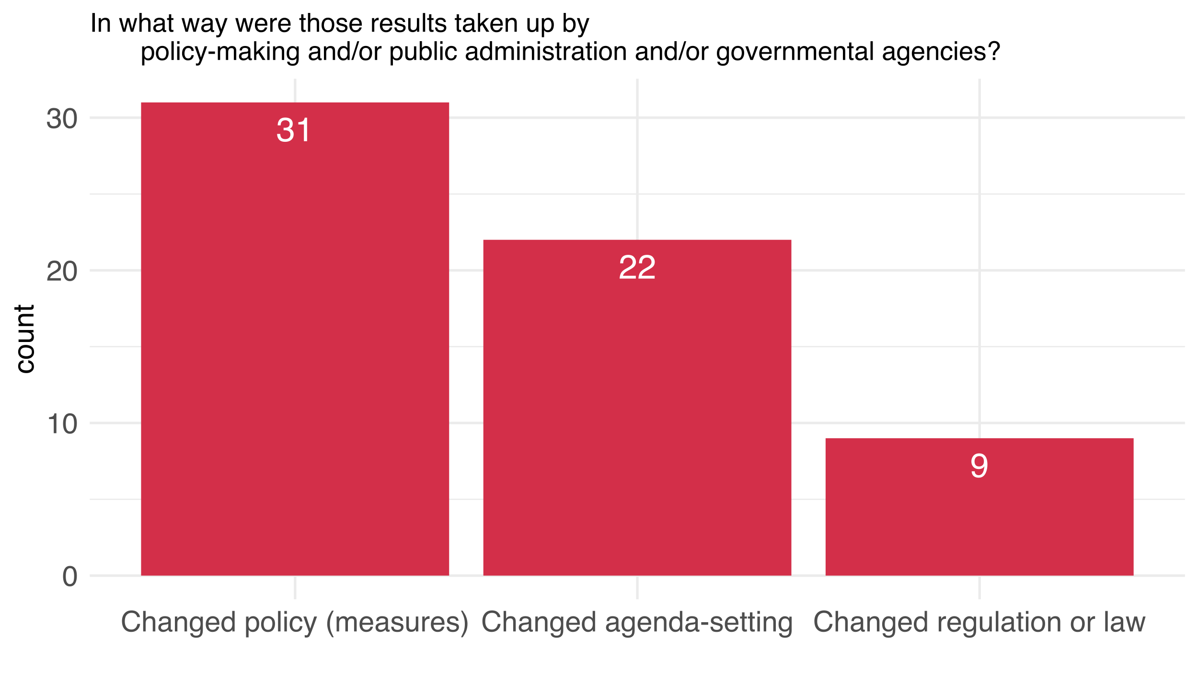

Figure 20: Nature of uptake

The nature of the policy uptake indicates what kind of a change the uptake by policymakers and public administration caused. The response rate to the question is fairly low (~17%). 9 respondents claim that the results of their projects changed/influenced laws and regulations and other 22 respondents note that the results changed a specific agenda-setting.

We assume that [H] the nature of involvement of policy makers have a statistically significant relation nature of policy uptake.

## Impact Statements

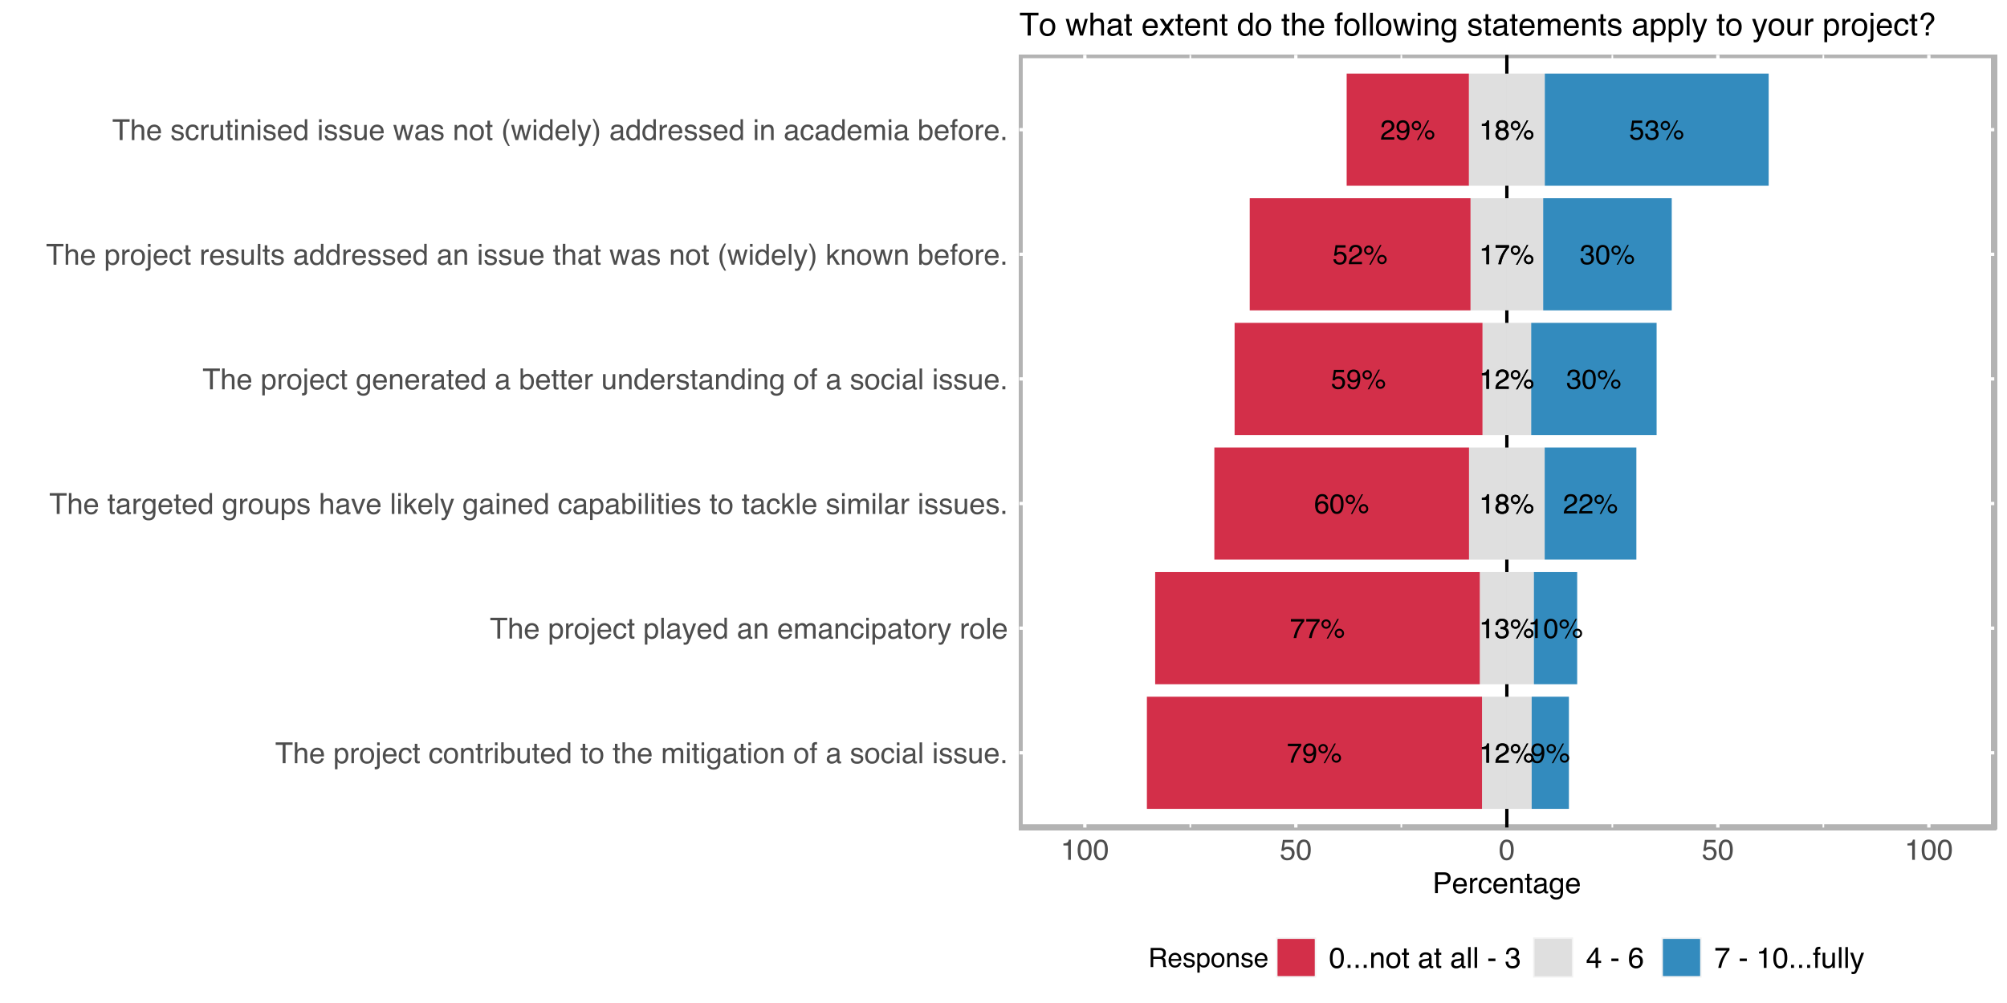

The last question in the outcome orientation section aimed to state specific questions about the impact of the project. The statements are chosen to address SI-relevant aspects directly. The academic dimension was by far the highest rated statement among the survey respondents, 53% of the respondents rated the statemet *the scrutinised issue was not (widely) addressed in academia before* 7 or higher on a scale from 0 to 10. This result is followed by a similar statement *the project results addressed an issue that was not (widely) known before* which was specifically directed to the novelty of the issue for the public, 30% of the respondents rated this statement 7 or higher, similarly the statement *the project generated a deeper/better understanding of social issue* was rated from the proportion of the respondents again 7 or higher.

As the intention and agency one of the pillars of the concept of social innovation, especially the strongly social innovation related statements should at least related to the deliberative action mobilized by the researchers’ initial motivation. We expect [H] a relation between motivation to improve human condition with the following statements:

* The project generated a better understanding of a social issue.
* The targeted groups have likely gained capabilities to tackle similar issues.
* The project played an emancipatory role.

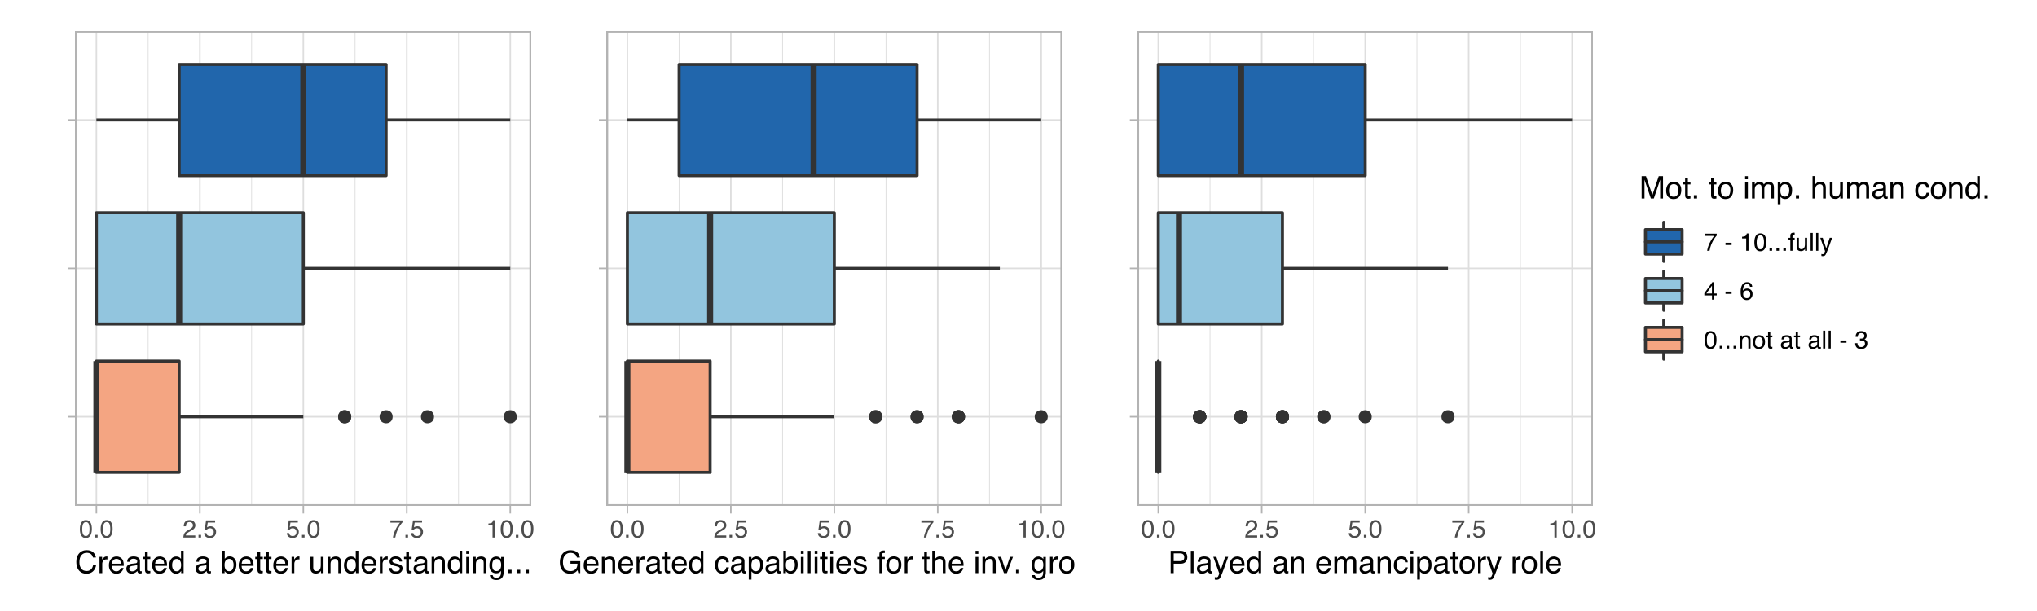

Figure 21: Relation between the social impact statements and the motivation to improve human condition

There is a moderately positive correlation between the motivation to improve human condition with each of the analysed impact statement variables (rho > 0.45 each). There seems to be somewhat higher rates in terms of creating a better/deeper understanding of a specific social issue, generating capabilities for the involved social groups to tackle similar issues in the future, and playing an emancipatory role in both participated and targeted social groups with higher motivation to improve human condition.

# Dissemination and Exploitation

## Dissemination Channels

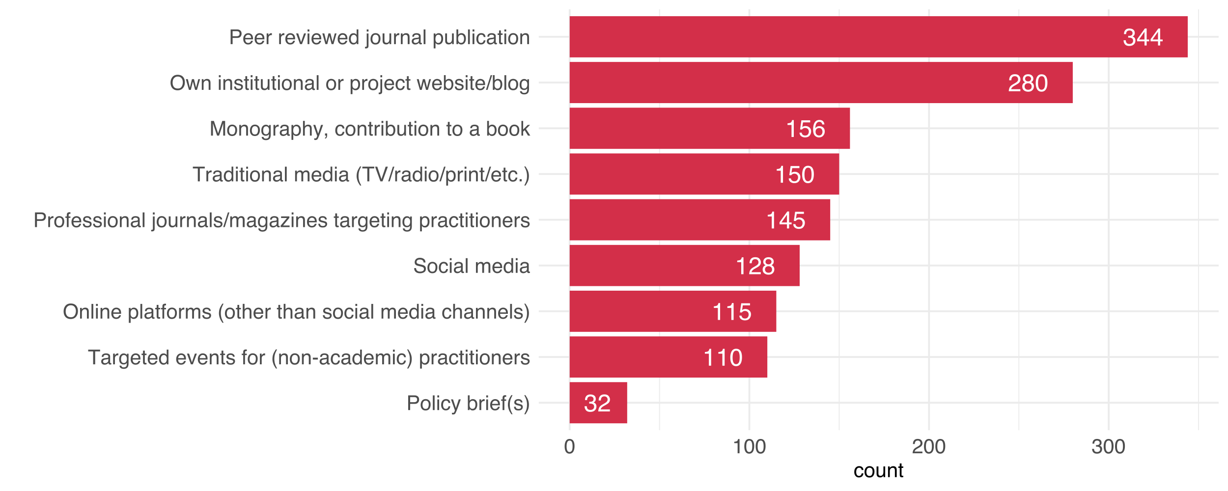

Figure 22: Distribution of dissemination channels

Chosen dissemination channels also deliver important information about the project. Some of the options like peer reviewed journal publications or the dissemination on the organisations’ own website have unsurprisingly high numbers. Policy briefs were rated lowest but 110 projects stated to have organised events for non-academic practitioners.

## Scalability

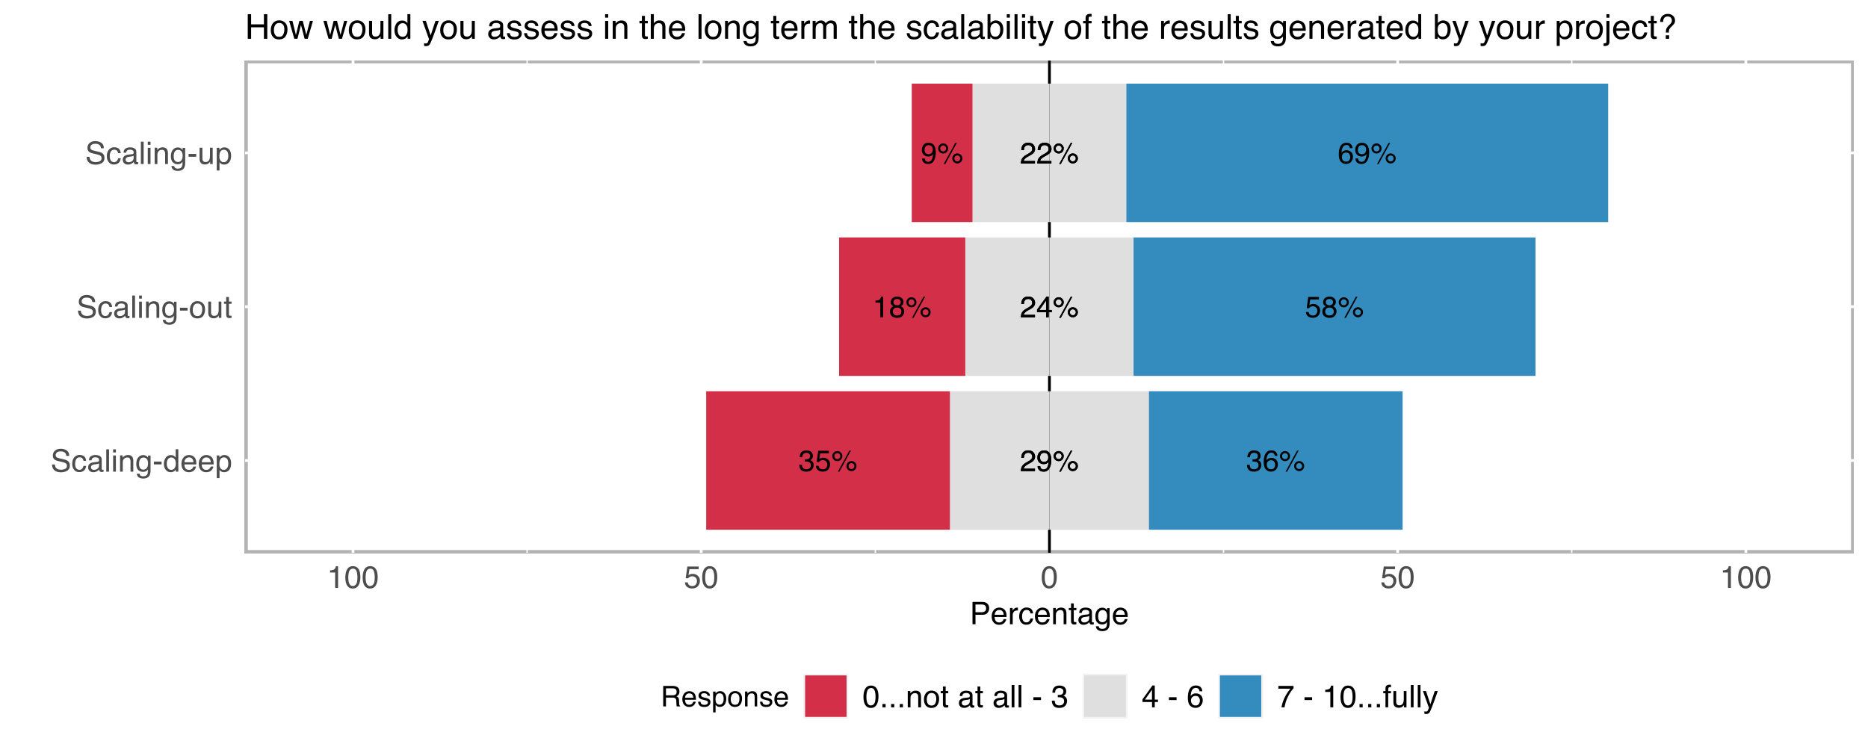

Figure 23: Distribution of scalability

The capability of the generated solutions to be applied in different contexts is another important goal in SI. 69% of the respondents noted that the solutions generated throughout the project had the high capability to be scaled up.

# SI Model

Generating a model to appproximate the SI-level in scientific projects was one of the important tasks of this study. Although the four pillars presented at the beginning of the study were the product of an already extensive literature research and analysis of other statistical approaches to SI, in order to test the reliability of our assumptions as well as the importance (for example how much variance each variable explain) of the preset features survey data played a crucial role.

After the preprocessing of the survey data, variable descriptions/visualisations, and the testing of literature driven hypotheses in the previous section creating an SI-Index was mostly a dimension reduction and data transformation Process. The first step of the dimension reduction process is carried out by the Principal Feature Analysis[10] (PFA) method. PFA is a modified appliance of more widely known Principal Component Analysis which aims to enable dimension reduction without representing the dataset matrix in a lower dimensional space. Therefore, PFA emphasizes the elimination of *less important* feature instead of finding a new representation of the data set. After the 10.000 iteration of the PFA method following variables which were frequently labeled as *not important* by PFA-algorithm have been removed from the further modelling considerations:

* Dissemination channels
* Open Science concepts
* Policy Uptake

Also the variables, *contribution to SI (self-assesment)* it will be a comparison variable for the SI-index generated by the modelling process and interdisciplinary involvement (participation of the researchers from other disciplines) because it was also a comparison variable for the transdisciplinary involvement, removed from modelling process.

After the feature elimination process further modelling has been carried out by Explanatory (EFA) and Confirmatory (CFA) Factor Analysis processes. In the explanatory phase after testing the optimal number of factors (eigenvalue analysis, elbow method on scree plot returned 8 as the optimal number) 6 different modelling approaches have been formulated. The best fitting/performing 3 models had the following characteristics:

1. A completely EFA driven model, following the exact clustering of the features by EFA
2. Semi-theory-driven model; after the analysis of factor loadings some of the variables which were not correlating too strong with the other factor members moved to the factors which were better fitting from the theoretical perspective of this study.
3. A completely PFA driven model where variables scaled by their *feature importance* determined through PFA iteration.

Semi-theory-driven model was the best performing model out of its other counterparts, 8 features of the model include the following variables[11].

|  |  |  |  |  |  |  |  |  |  |
| --- | --- | --- | --- | --- | --- | --- | --- | --- | --- |
| **SI & Trandisciplinarity Familiarity** | **Intention & Agency** | transdisciplinary_apects |  |  |  |  |  |  |  |
| familiarWithSI.response. | motivation.welfare. |  |  |  |  |  |  |  |  |
| transdisciplinaryExp.rate. | benefitForNonAcademy |  |  |  |  |  |  |  |  |
|  | impulseForNonAcad.soc. |  |  |  |  |  |  |  |  |
|  | targetGroupsGoals.improve. |  |  |  |  |  |  |  |  |
|  | impulseForNonAcad.health. |  |  |  |  |  |  |  |  |
|  | impulseForNonAcad.ecol. |  |  |  |  |  |  |  |  |

As a further comparison of SI-index derived from the most performant model (semi-theory-driven model) with the self-assessment SI-Rate can be seen on Figure 24. Variables are not identical but they show a relatively strong correlation (rho = 0.7).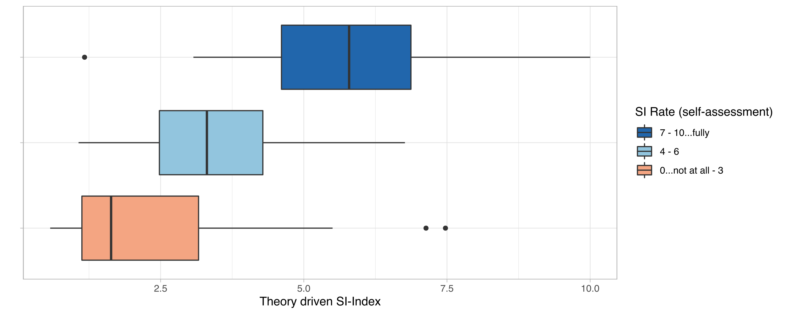

Figure 24: Relation between self-assessment SI-rate and theory driven SI-index

1. The term scientific domain is used to refer to the overarching categories of scientific disciplines. SNF documents already include a specific classification system which we have followed throughout the analysis process, we have also tried to stay consistent with colors associated with each scientific domain on different visualisations. Those categories are as follows:

   Biology and Medicine

   Mathematics, Natural –, and Engineering Sciences

   Social Sciences and Humanities
2. A detailed analysis of these variables can be found in Section *Intention & Agency.*
3. After the consideration of dominant variable types and distributions as well as the often non-linear relationships between variables, Spearman correlation chosen to be the method to be applied in most cases in the analysis of the survey. The correlation coefficient will be noted with the English spelling of the common symbol of Spearman’s rank correlation coefficient symbol **ρ**, as **rho**. The reason for the decision regarding the presentation of **ρ** is to draw a clear distinction between **ρ (rho)** and **p** which will be also often mentioned in the parentheses as in **p-value**.
4. Study wide α value is 0.05
5. Results of the pairwise comparisons using Wilcoxon rank sum test with continuity correction (Bonferonni) p-value adjustment yields a p-value greater than 0.05 for Mathematics, Natural-, & Engineering Sciences. SSH, however, associated with p-values significantly smaller than 0.05 in comparison with both of the other domains
6. For a detailed analysis of the variables, see Section *Outcome-orientation.*
7. Cargo and Mercer, ‘The Value and Challenges of Participatory Research’.
8. The concept of scalability has been operationalized under 3 different categories in the survey (deep -, out -, and up scalability), however, after a dimension reduction process in the analysis (explanatory and confirmatory factor analysis), it has been decided to compile the sub-variables of scalability into one single scalability variable because of the similarity of their explained variances. Either because of the similarity of concepts or because of the lack of the knowledge on different forms of scalability the responses under different categories were highly similar.
9. Noi: Nature of Involvement.

   KoC: Kind of Change.
10. Lu et al., ‘Feature Selection Using Principal Feature Analysis’.
11. Features of each model have been scaled according to the variance they’ve explained.